Passengers

Time series plot

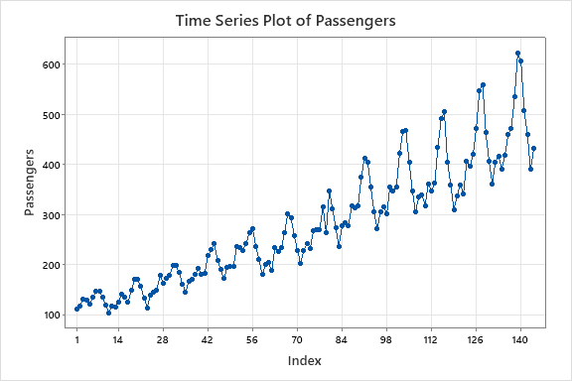

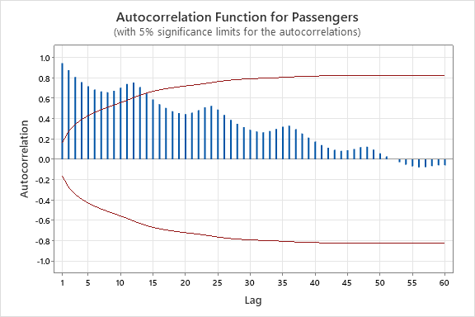

ACF Function has a seasonal variation. Therefore, the series is non stationary. Therefore, we have to do a seasonal difference.

ACF for seasonally differenced data

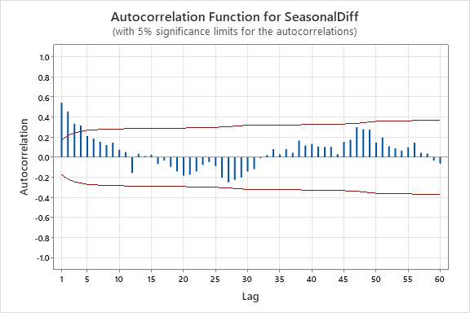

ACF has quickly dies down pattern, therefore seasonally difference series is stationary.

Autocorrelations

Lag ACF T LBQ

1 0.544019 6.25 39.96

2 0.457163 4.16 68.40

3 0.335136 2.72 83.80

4 0.315917 2.43 97.59

5 0.210989 1.55 103.79

6 0.186681 1.35 108.68

7 0.153368 1.09 112.01

8 0.122726 0.87 114.16

9 0.146420 1.03 117.24

10 0.074455 0.52 118.05

11 0.051152 0.36 118.43

12 -0.156030 -1.09 122.02

24 -0.047486 -0.31 142.31

36 0.081542 0.50 184.80

48 0.280645 1.61 249.64

60 -0.063353 -0.34 293.31

PACF for seasonally differenced data

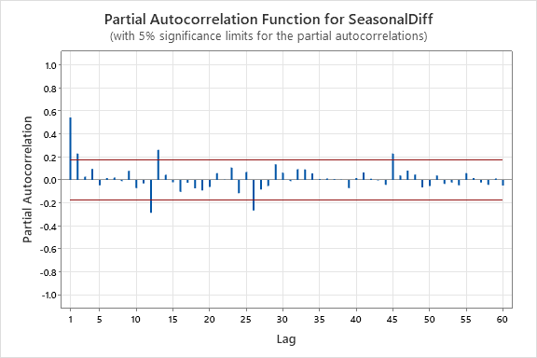

Partial Autocorrelations

Lag PACF T

1 0.544019 6.25

2 0.228973 2.63

3 0.028197 0.32

4 0.094354 1.08

5 -0.046856 -0.54

6 0.017127 0.20

7 0.020805 0.24

8 -0.010929 -0.13

9 0.078824 0.91

10 -0.071341 -0.82

11 -0.030687 -0.35

12 -0.285888 -3.28

24 -0.116387 -1.34

36 0.011207 0.13

48 0.046328 0.53

60 -0.049360 -0.57

PACF cuts off at non seasonal lag 2 and seasonal lag 1.

Tentative Model 01

SARIMA(2,0,0)(1,1,0)12

**2nd Model**

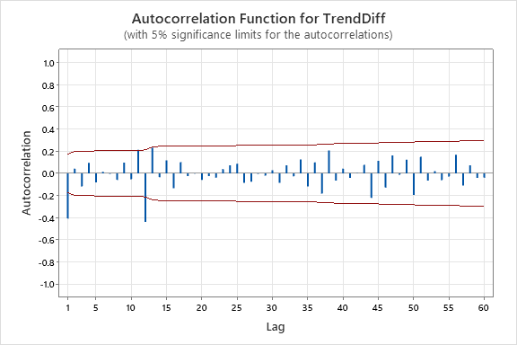

Autocorrelations

Lag ACF T LBQ

1 -0.408610 -4.68 22.38

Over differenced

2 0.041966 0.42 22.61

3 -0.117192 -1.16 24.48

4 0.094450 0.93 25.71

5 -0.082090 -0.80 26.64

6 0.013288 0.13 26.66

7 -0.004091 -0.04 26.67

8 -0.059525 -0.58 27.17

9 0.097453 0.94 28.52

10 -0.053292 -0.51 28.93

11 0.212140 2.03 35.47

12 -0.437388 -4.06 63.48

13 0.232163 1.93 71.44

14 -0.035416 -0.29 71.62

15 0.116686 0.94 73.67

16 -0.133337 -1.07 76.36

17 0.101308 0.81 77.93

18 -0.023466 -0.19 78.02

19 -0.001182 -0.01 78.02

20 -0.059555 -0.47 78.57

21 -0.024258 -0.19 78.67

22 -0.038704 -0.31 78.90

23 0.038533 0.30 79.14

24 0.073661 0.58 80.03

25 0.087766 0.69 81.29

26 -0.085806 -0.67 82.52

27 -0.075094 -0.59 83.46

28 -0.003251 -0.03 83.46

29 -0.020869 -0.16 83.54

30 0.029078 0.23 83.68

31 -0.085084 -0.66 84.94

32 0.072738 0.56 85.87

33 -0.026142 -0.20 86.00

34 0.125121 0.97 88.81

35 -0.118711 -0.91 91.37

36 0.100094 0.76 93.20

37 -0.182155 -1.38 99.35

38 0.205936 1.54 107.30

39 -0.064199 -0.47 108.08

40 0.043555 0.32 108.44

41 -0.039949 -0.29 108.75

42 0.002450 0.02 108.75

43 0.077881 0.57 109.95

44 -0.221796 -1.62 119.80

45 0.114125 0.82 122.44

46 -0.128489 -0.92 125.83

47 0.162566 1.15 131.31

48 -0.012943 -0.09 131.34

49 0.124377 0.87 134.63

50 -0.193987 -1.35 142.73

51 0.149665 1.03 147.60

52 -0.065349 -0.45 148.55

53 0.019613 0.13 148.63

54 -0.061142 -0.42 149.48

55 -0.027805 -0.19 149.65

56 0.168156 1.14 156.22

57 -0.108686 -0.73 159.00

58 0.072540 0.49 160.26

59 -0.041465 -0.28 160.68

60 -0.039044 -0.26 161.05

**Final Estimates of Parameters**

|  |  |  |  |  |
| --- | --- | --- | --- | --- |
| **Type** | **Coef** | **SE Coef** | **T-Value** | **P-Value** |
| AR   1 | 0.5107 | 0.0863 | 5.91 | 0.000 |
| AR   2 | 0.2272 | 0.0860 | 2.64 | 0.009 |
| SAR  12 | -0.4368 | 0.0855 | -5.11 | 0.000 |
| Constant | 11.85 | 1.38 | 8.58 | 0.000 |